



**Model Development Phase Template**

|  |  |
| --- | --- |
| Project Title | Harvesting Brilliance : A Taxanomic Tale of  Pumpkin Seeds Varieties |
| Maximum Marks | 4 Marks |

**Initial Model Training Code, Model Validation and Evaluation Report**

The initial model training code will be showcased in the future through a screenshot. The model validation and evaluation report will include classification reports, accuracy, and confusion matrices for multiple models, presented through respective screenshots.

**Initial Model Training Code:**

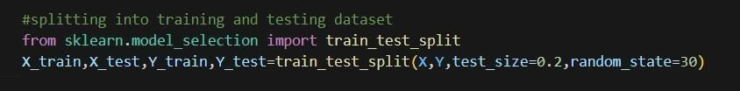

|  |  |  |
| --- | --- | --- |
| **Model** | **Classification Report&**  **Accuracy** | **Accuracy** |

**Model Validation and Evaluation Report:**

|  |  |  |
| --- | --- | --- |
| Random forest  classifier |  | 0.875 |

|  |  |  |
| --- | --- | --- |
| Logistic regression |  | 0.86 |

|  |  |  |
| --- | --- | --- |
| Decision Tree classifier |  | 0.82  0.81  0.66 |
| Naïve Bayes |
| Gradient Boosting Classifier |
| Support vector  classifier | 0.88 |